

**American International University-Bangladesh (AIUB)**

**Department of Computer Science**

**Faculty of Science &Technology (FST)**

**Summer 2021**

**Software Engineering Section:** B

**Search food and Product system**

A Software Engineering Project Submitted

By

Mohammed Ibrahim Shawon   
 19-40767-2   
 BSC, CSE

**Software System**

**Search food and Product system**

**Features**

Features are listed below.  **High**, **Medium** and **Low** are used to indicate the importance of each feature.

|  |  |  |  |
| --- | --- | --- | --- |
| **Feature ID** | **Description** | **Priority** | **Requester** |
| **FE01** | software based and accessible from devices (with internet connection) such as desktop, laptop, mobile and tablet PCs. | High |  |
| **FE02** | Accessible to general users who have account. | High |  |
| **FE03** | Seller data management for example:  personal details, training history, promotion history and so on.  It will also allow restaurant/shop search and viewing list | High |  |
| **FE04** | Report generation based on user needs and payment system | Medium |  |
| **FE05** | User can review and rate food and items | High |  |
|  |  |  |  |

**Use case diagram**

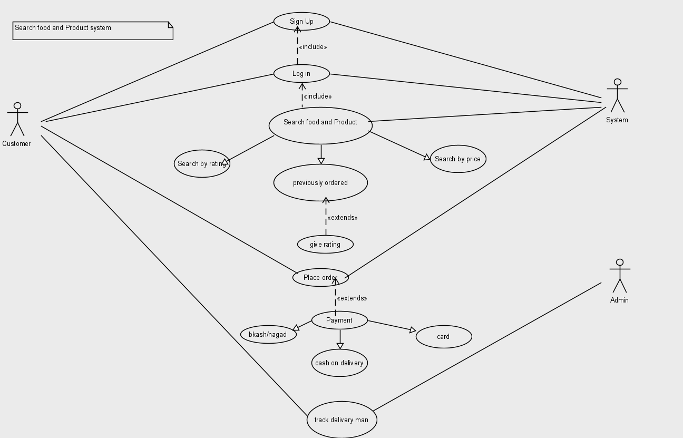

**Use Cases**  
These are the overall use cases for the user .

|  |  |
| --- | --- |
| **FE02 - Authentication and authorization** | |
| **FE02_UC01** - User authentication | |
| **Brief Description** | The user opens up the application in search of food and products. the app will enable location and will show the available food and product nearby. |
| **Pre-condition/s** | * User has an account in the system * Internet and gps |
| **Priority** | High |
| **Actor/s** | Users of all classes. |
| **Main Success Scenario** | 1. User opens up the portal 2. The system displays a login form 3. User enters his/her user id and password 4. The system matches user credentials against its date store 5. The system then redirects user to the appropriate page based on user class. |
| **Alternative Scenario** | * The system cannot find a match for the user and re-displays the login form with an error message. * The system runs into internal error (i.e. database unavailable) and notifies user and asks the user to contact administrator. |
| **Notes/Questions** | Must need clarification on dashboard for each user type. |

|  |  |
| --- | --- |
| **FE03 - Seller data management** | |
| **FE03_UC01** - Add new Seller | |
| **Brief Description** | User wants to add a new seller and the system displays form to add seller data. |
| **Pre-condition/s** | * User must be logged in * User must have authorization to add employee |
| **Priority** | High |
| **Actor/s** | ADMIN , SYSTEM |
| **Main Success Scenario** | 1. The system displays a form with all the necessary fields required to collect seller information. These fields will be shop/restaurants Present Address, Permanent Address, E-mail Id, Contact Number, product and food Information, price range and so on. 2. The system automatically generates an seller ID to the new seller. 3. The ‘must be filled’ fields are marked with a red asterisk. 4. Authentication for email. 5. Authentication for contact number. 6. When all the information is put the system generates a successful operation message and updates all the information properly in the database. |
| **Alternative Scenario** | * The system is unable to store the information in database and generates operation not complete message. |
| **Notes/Questions** | The system will not store information from incomplete form. A form will be incomplete when all the ‘must be filled’ fields are not filled. |
|  | |
| **FE03_UC02** - View seller list | |
| **Brief Description** | The system will display seller information |
| **Priority** | High |
| **Actor/s** | ADMIN, SYSTEM |
| **Main Success Scenario** | 1. The user can generate a list of seller based on different view requirement 2. The seller list will be displayed in a single organized page |
| **Alternative Scenario** | * The system is unable to extract seller information from the database and generates error message |
| **Notes/Questions** | The types of views must be mentioned |

**Non-Functional requirements**

**1.** User can contact with seller about new offer to attract new customers which will be set in system **.**

**2.** Option can be add for affiliate marketer .